**1  How Many Ways？**

Time Limit:500MS  Memory Limit:65535K

题型: 编程题   语言: 无限制

**描述**

You live in a small well-planned rectangular town. The size of the central area of the town is H kilometers from South-to-North and W kilometers from West-to-East. The central area is divided into HW unit blocks, each of size 1×1 km2. There are H + 1 streets going in the West to East direction, and there are W + 1 avenue going in the North to South direction. The central area can be seen as a rectangle on the plane, as shown below.

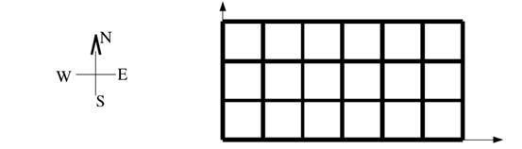

Figure 1. The central area for a town where H = 3, and W = 6.

We can identify each intersection by its co-ordinate on the plane. For example, on the Figure above the bottom-left corner is intersection (0, 0), and the top-right corner is intersection (6, 3). Your house is at the bottom-left corner (i.e., intersection (0, 0)) and you want to go to the university at the top-right corner (i.e., intersection (***W***, ***H***)). Moreover, you only want to go to the university with wasting any efforts; therefore, you only want to walk from West-to-East and South-to-North directions. Walking this way, in the example above there are   ways to reach the university.

You want to go to the university. Things get more complicated if the city blocks parts of intersections to do some cleaning. The blocking intersections are such a way that it is not possible to cross. You still want to go to the university using the same West-to-East and South-to-North strategy. You want to find out how many ways you can reach the university by only walking West-to-East and South-to-North.

**输入格式**

The first line contains an integer ***T***, the number of test cases **(1 ≤ T≤ 1000)**. Each test case is in the following format.

The first line of each test case contains 3 integers: ***W***, ***H***, and ***K*** **(1≤W≤1000; 1≤H≤1000; 0≤K≤10).** ***W*** and ***H*** specify the size of the central area. ***K*** denotes the number of blocked intersections.

The next ***K*** lines describe the information of blocked intersections. More specifically, line ***1+i***, for **1<i<K**, contains two integer: ***wi***, ***hi*** **(0≤wi≤W, 0≤hi≤H)**. The intersection **(wi, hi)** are blocked.

**输出格式**

For each test case, your program must output the number of ways to go to the university on a separate line. Because the answer may be quite large, you should give answer mod***19992010***.

**输入样例**

3

2 2 1

1 1

6 3 2

1 1

2 2

9 6 3

1 2

2 1

4 4

**输出样例**

2

32

934